|  |  |
| --- | --- |
| Name | Umar Hayyat |
| Roll no. | 2019-EE-360 |
| Marks |  |

**Lab 1**

**Introduction to MATLAB for Control system**

**Objective:**

Analysis of the MATLAB and its use for the control systems.

**Overview:**

MATLAB is a professional software used for technical computing. MATLAB stands for Matrix Laboratory. In this lab manual we are using some of the basic commands and learn how to use the control system in this software. Previously we have done use this software for data structures and it contains the built-in debugging tools and editing. It is an outstanding tool software for the engineering students.

**Exercise 1:**

Use Matlab command to obtain the following

1. Extract the fourth row of the matrix generated by magic (6).
2. Show the results of ‘x’ multiply by ‘y’ and ‘y’ divides by ‘x’.

Given x = [0:0.1:1.1] and y = [10:21]

1. Generate random matrix ‘r’ of size 4 by 5 with number varying between -8 and 9

**Output (a):**

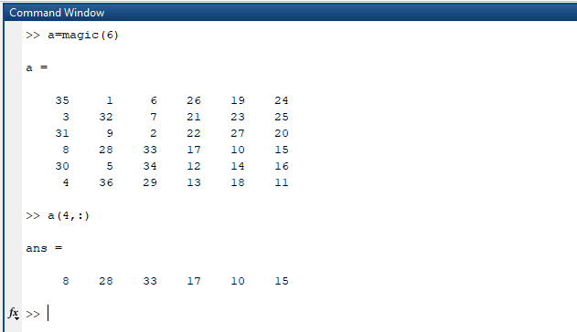

**Output (b):**

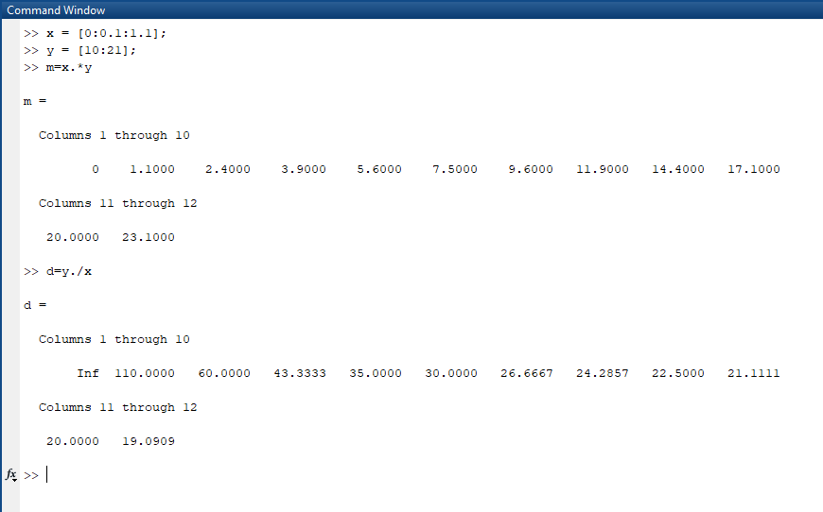

**Output (c):**

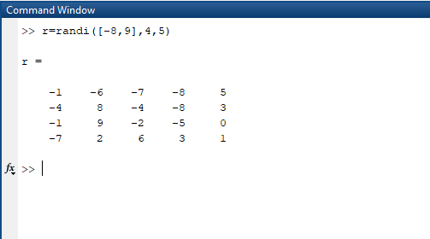

**Exercise 2:**

Use MATLAB commands to get exactly as the figure shown below

x = pi/2 : pi/10 : 2*pi;

y = sin (x) ;

z = cos(x) ;

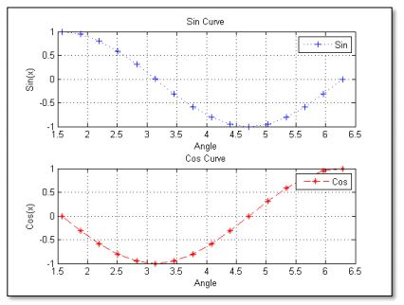

**Output:**

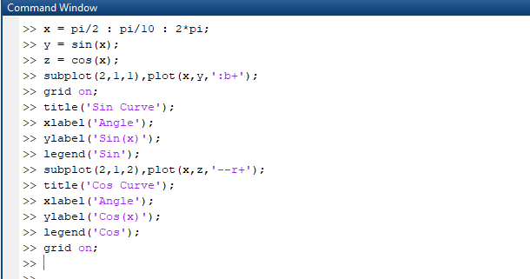

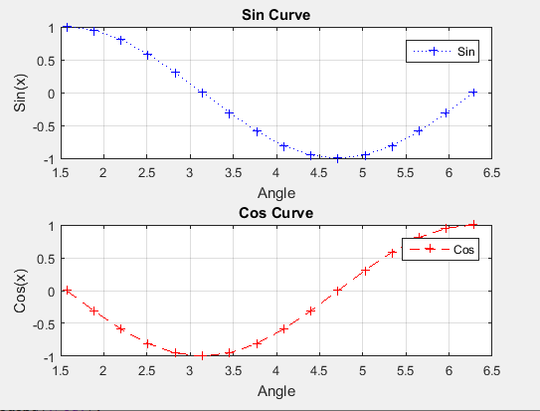

**Conclusion:**

In this lab, I learned how to use command window of MATLAB. I also learned how to create matrix and perform different operation on it i.e extract any row or column. I also learned how to use rand(n) and magic(n) commands. rand(n) command gives nxn matrix having elements varying from 0 to 1. I learned how to plot graph in MATLAB and change the color and style of curve.